Costlier Candles, Quiet Prophets: How Religion Meets Inflation in the Croatian Digital Media Space, 2021–2026
LUKA ŠIKIĆ, doc. dr. sc. * Catholic University of Croatia (Hrvatsko katoličko sveučilište) Department of Communication Studies Zagreb, Croatia
PETRA PALIĆ, izv. dr. sc. Catholic University of Croatia (Hrvatsko katoličko sveučilište) Department of Communication Studies Zagreb, Croatia
MISLAV SAGOVAC, dr. sc. Catholic University of Croatia (Hrvatsko katoličko sveučilište) Department of Communication Studies Zagreb, Croatia
Original scientific paper UDK: [to be assigned by the journal] doi: [to be assigned by the journal] Received: [month and year, assigned upon submission]

Catholic Social Teaching (CST) calls the Church to name inflation as an injustice against the poor. We ask how that voice actually sounds in a national digital media space during a cost-of-living shock. From the DigiKat corpus of 710,307 religion-salient Croatian and Bosnian media posts (2021–2026), we isolate inflation mentions and separate genuine religion-inflation linkage from incidental co-occurrence. After coding 1,450 candidates with three language-model annotators, a measured domestic core of 520 posts remains. Within it, religion meets inflation overwhelmingly as an economic object: the rising cost of religious life and the Church as an institution together account for about 72% of posts, while the structural-justice register CST foregrounds reaches at most 8%. Media attention tracks real prices (Pearson r about 0.73), yet the religious justice voice does not fill it. In keyword-filtered corpora, co-occurrence is not engagement, and linkage must be measured, not counted.
Keywords: digital religion, inflation salience, Catholic Social Teaching, media framing, agenda-setting, Croatia, computational text analysis.

* Corresponding author: Luka Šikić, doc. dr. sc., Catholic University of Croatia, Department of Communication Studies / Hrvatsko katoličko sveučilište, Odjel za komunikologiju, Ilica 242, 10000 Zagreb, Croatia / Hrvatska, luka.sikic.gm@gmail.com

INTRODUCTION
Between 2021 and 2026 Croatia lived through the sharpest cost-of-living shock in a generation, compounded by the adoption of the euro on 1 January 2023. Catholic Social Teaching has an unusually explicit stance on such moments: from the “preferential option for the poor” to Pope Francis’s “this economy kills” (ova ekonomija ubija), doctrine frames economic hardship as a structural injustice the Church is called to name on behalf of the vulnerable. In a country where the Catholic Church is a dominant cultural institution and operates one of Europe’s more developed religious media ecosystems, one might expect the digital public sphere to carry an audible religious-economic voice when prices spike.
This paper asks a deliberately simple question: when inflation surfaces in religion-salient Croatian digital discourse, who carries it, and in what register? We do not assume the Church is loud on the economy. We measure whether it is, and how. The answer turns out to be less about prophecy than about price lists.
Three contributions follow. Substantively, we provide the first measurement of the religious register of inflation discourse across an entire national digital media space, and we document a gap between CST’s normative promise and observed practice. We combine this description with three hypotheses and three theory-derived propositions (see below). One of them, that media inflation-attention tracks real prices, is tested quantitatively against the Harmonised Index of Consumer Prices (HICP) and found to be partially supported. Another, the CST-derived expectation of a prophetic justice voice, is evaluated and found not to be visible in the digital-news measure, since a news corpus cannot test the actor-level claim about the Church itself. Methodologically, we show that the naïve approach of counting posts where religion and inflation co-occur overstates genuine engagement by roughly an order of magnitude (about 8,000 co-mentions versus 520 measured), and we demonstrate a validated pipeline for measuring linkage rather than co-occurrence.

BACKGROUND AND HYPOTHESES
The study sits at the intersection of three literatures that are each well developed but rarely meet.
Public and media attention to inflation is non-linear. It stays flat until inflation crosses a threshold of roughly 2 to 4%, then jumps (Korenok, Munro and Chen, 2026; Pfäuti, 2024). Coverage is less about the headline rate than about who is hurt and which component, reflected in the “heating or eating” framing of food versus energy (Champagne et al., 2024). The European Central Bank now maintains a dictionary-based media inflation-attention index (Aarab et al., 2025). Agenda-setting theory (McCombs and Shaw, 1972) is the backdrop, with an open question of whether media set or merely reflect attention (Wlezien and Soroka, 2024). A second level of that theory matters here. Attribute agenda-setting (McCombs, 2004) holds that media transfer not only the salience of an issue but the salience of its attributes. Our register question is precisely an attribute question: it asks not whether religion-and-inflation is on the agenda, but which of its faces (the fee, the charity, the injustice) becomes salient. This literature is almost entirely secular and Anglophone or euro-area. It says nothing about the religious media sphere as an inflation channel.
A second literature concerns CST economic framing. The theological distinction between charity (relieving symptoms) and justice (changing structures) maps closely onto Iyengar’s (1991) episodic-versus-thematic framing and gives us a measurable construct. The structural critique is not only a Francis-era phenomenon (Benedict XVI, 2009; Francis, 2013). But existing studies examine secular press coverage of poverty, not religious media as the storyteller.
A third literature concerns Croatian Catholic media, which are well studied on identity, nation, and culture-war themes, but whose coverage of the economy has never been measured, still less linked to a live cost-of-living shock.
A gap follows, along with a fourth, methodological one. No work has asked what register religion takes when it meets inflation in a whole national digital space. And studies of “religion and X” in large corpora routinely equate co-occurrence with engagement. We show below why that is unsafe here.

Hypotheses and propositions
The study is primarily descriptive, but prior theory licenses explicit, testable expectations. We state three directional hypotheses, each predicting a pattern that the data allow us to test formally, and three propositions, evaluated by pattern-matching against the coded evidence in the interpretive tradition (Yin, 2018).
The first hypothesis (H1) concerns attention and prices. From inflation-salience and agenda-setting theory, media attention to inflation should rise with the real HICP and jump once inflation crosses a threshold of about 4%, with the food and energy components at least as salient as the headline rate. We test it against the Croatian HICP with a correlation and a threshold contrast.
The second hypothesis (H2) concerns who carries which register. Attribute agenda-setting holds that different outlets make different attributes of an issue salient (McCombs, 2004), and the idea of a division of narrative labour suggests that secular and religious outlets tell different stories about the same shock. The register in which religion meets inflation should therefore depend on the type of outlet, rather than being the same across the media space. We test this with a chi-square test of independence between register and outlet type.
The third hypothesis (H3) concerns tone. The tone of inflation news, not only its volume, shapes how audiences read it (Lamla and Maag, 2012), and a complaint about rising religious costs is a different kind of story from pastoral commentary or a relief appeal. The tone of a post should therefore depend on its register. We test this with a chi-square test of independence between register and tone.
Three propositions follow, evaluated by pattern-matching rather than a formal test. The first (P1) concerns resonance rather than setting: religious inflation coverage should resonate with real conditions rather than lead them, entering the discourse reactively as an affected party. The second (P2) is the prophetic-actor proposition: if the Church acts as a prophetic economic voice in the digital public sphere, the structural or CST-justice register should be non-trivial and should rise with hardship. The third (P3), following Iyengar (1991), holds that framing should be episodic rather than thematic, with relief, institutional, and price-of- service framing dominating the structural critique.
We keep the inferential machinery modest and matched to what observational data of this kind can bear. The three hypotheses are tested with a correlation, a threshold contrast, and two chi-square tests, and the three propositions are evaluated by pattern-matching against the register distribution and its time path.

DATA AND METHODS
The DigiKat master is a topical corpus of 710,307 Croatian and Bosnian media posts collected continuously from January 2021 to June 2026. A post enters the corpus when it contains at least two distinct religious terms. The corpus therefore holds religion-salient posts from across the whole media space, not a Catholic-outlet archive. Secular mainstream outlets dominate, and 96% of the core is web-portal content, with 2% from Facebook and the rest negligible. Collection intensity was not perfectly uniform over the six years, so year-to-year volumes are best read as indicative rather than exact.
To identify the relevant posts, we tagged every post whose title or body matches an anchored inflation lexicon. The lexicon covers words for inflation and rising prices, such as inflacija, poskupljenje (“becoming more expensive”), rast cijena (“price rises”), trošak života (“cost of living”), and kupovna moć (“purchasing power”), while deliberately excluding the bare word cijena (“price”) to avoid devotional false positives such as “the price of salvation”. A metaphor guard removes figurative uses such as “inflation of words” or “inflation of values”. This yields 8,019 clean inflation-mentioning posts, or 1.13% of the corpus.
Mentioning inflation is not the same as being linked to it. A long news article can mention inflation in one paragraph and a saint’s feast in another with no connection. We therefore measured, for each inflation post, whether a religious term (project lexicon of 95 terms, tightened for economic homonyms such as gospodarstvo “economy” vs Gospa “Our Lady”) appears within ±220 characters of an inflation mention. This proximity filter is deliberately recall-oriented (validated recall ≈0.89): it generates 1,450 candidate linked posts while accepting false positives, which the coding stage removes. We code the full linked set (1,450) rather than the classifier’s narrower domestic-linked subset (1,103), because the automatic foreign/domestic flag is unreliable (held-out precision of about 0.39). The annotators, not the flag, decide foreign versus domestic.
The candidates were then coded. All 1,450 candidates were coded by three independent annotators, each a large language model applying the same fixed codebook, and the final label for each post was the majority of the three. Of the 1,450 posts, 1,447 were coded by all three annotators. Each post was judged on four axes.
The first axis asked whether the post is genuinely about inflation or the cost of living, rather than using an inflation word only in passing. The second, and most important, asked whether religion is genuinely connected to that economic content. Here the annotators had to rule out the many ways religion and inflation can appear together with no real link. A church might be named only as a geographic landmark, the word “inflation” might be a metaphor such as an “inflation of values”, a religious term might sit in a hashtag, or it might belong to a secular organisation whose name merely contains a religious word, as with Crveni križ (the Red Cross) or a Papa-test (a Pap smear). A post counted as linked only when the religious element and the inflation element belonged to the same story rather than to two unrelated parts of a long article. The third axis asked whether the inflation in question was domestic or foreign, since Croatian media report price rises abroad frequently and those cases had to be separated from the domestic one. The fourth axis, applied only to genuinely linked posts, recorded the register in which religion met inflation: the cost of religious life (the price of religious goods or services rising), the Church as an institution (clergy, the Pope, or a parish acting or commenting), structural or CST justice, charity (Caritas and relief work), devotional framing, or other. The register was the hardest judgement, because a post could touch more than one, so annotators assigned the register that best captured its main emphasis.
We validated the coding on a stratified held-out sample of 80 posts, disjoint from any tuning data. Inter-annotator agreement was high (infl 0.975, link 0.967, foreign 0.992), confirming that the constructs are reliably measurable. Register is the harder judgement, with a held-out agreement of only 0.46. The proximity filter’s held-out precision for domestic linkage was modest (about 0.38 to 0.46) with a recall of about 0.89, meaning it functions as a filter rather than a labeller. The full-pool coding confirmed this, with 45% of candidates coded as genuinely linked. We therefore report coded figures throughout and never regex counts. Annotators are LLM-based, so the agreement reflects inter-model reliability rather than a human gold standard, and a human double-coding pass is planned (see Limitations).
For the price comparison, the Croatian HICP annual rate of change (monthly, covering all items, food, and energy) was obtained from Eurostat for 2021 to 2025.
The analysis that follows reports three things: the path from the full corpus down to the measured core, the register distribution together with its outlet, temporal, and tonal structure, and a test of the first hypothesis relating monthly inflation-attention to HICP.

RESULTS

Co-occurrence is not engagement
The path from corpus to measured core is steep (Table 1). Of 710,307 posts, 8,019 (1.13%) mention inflation. Of those, the recall-oriented filter flags 1,450 as candidate-linked, and coding confirms only 652 as genuine religion–inflation linkage. Of these, 132 concern foreign inflation, leaving a domestic measured core of 520 posts, 0.07% of the corpus and 6.5% of inflation-mentioning posts. A naïve co-occurrence count would have reported the phenomenon as an order of magnitude larger than it is. Even among the proximity-flagged candidates, just 45% survive coding. The 520 is itself a floor rather than a point estimate. At the filter’s validated recall of about 0.89, estimated on an 80-post held-out sample, roughly sixty genuine domestic posts are missed before coding, giving a recall-corrected estimate of about 584. All shares below use the measured 520 as the denominator.
Table 1 From corpus to measured core
Stage | n | % of corpus
Full religion-filtered corpus | 710,307 | 100.000
Mentions inflation (clean) | 8,019 | 1.129
Linked candidates (filter, recall ≈0.89) | 1,450 | 0.204
Confirmed religion-linked (coded) | 652 | 0.092
… foreign inflation | 132 | 0.019
… domestic (measured core) | 520 | 0.073
Source: Authors’ calculation from the DigiKat corpus.

Who carries it
Genuine religion-and-inflation discourse is overwhelmingly a secular-media phenomenon. Of the 520 posts, 442 (85%) come from secular or mainstream outlets, 75 (14%) from Catholic outlets, and only 3 from the business press (Table 3). The single largest producer is the Catholic aggregator hkm.hr, with 56 posts. It is followed by mainstream titles such as slobodnadalmacija.hr (17 posts), novilist.hr (16), 24sata.hr (12), jutarnji.hr (11), and večernji.hr (10). The Church’s own outlets are not where this discourse mainly lives.

The register of religious-economic discourse
The central result is the register distribution (Table 2, Figure 1). Religion meets domestic inflation as, in order: the cost of religious life (37.3%), the Church as an institution (34.4%), charity (16.7%), devotional framing (5.0%), and the structural or CST-justice register at just 2.9%, or 15 posts.
Two cautions attach to this table. First, the two leading registers are close in size, share the same vocabulary (words like crkva and biskup), and register was the axis annotators agreed on least (agreement of 0.46), so their exact ordering falls within coding noise. The safe statement is that together they form an economic-object macro-register of about 72%, or 373 posts. Second, the 3% justice figure is a strict floor. If we also count posts placed in other registers whose text still carries a structural argument, chiefly charity posts such as Caritas discussing structural poverty, the figure rises to at most 8%, or 43 posts. Justice is marginal on either definition.
Table 2 Register of the domestic core (n = 520)
Register | n | %
Cost of religious life | 194 | 37.3
Church-as-institution | 179 | 34.4
Charity / relief | 87 | 16.7
Devotional | 26 | 5.0
Structural / CST justice | 15 | 2.9
Disputed (pending human tiebreak) | 12 | 2.3
Other | 7 | 1.3
Source: Authors’ calculation from the DigiKat corpus.
Figure 1 Register composition of the measured core
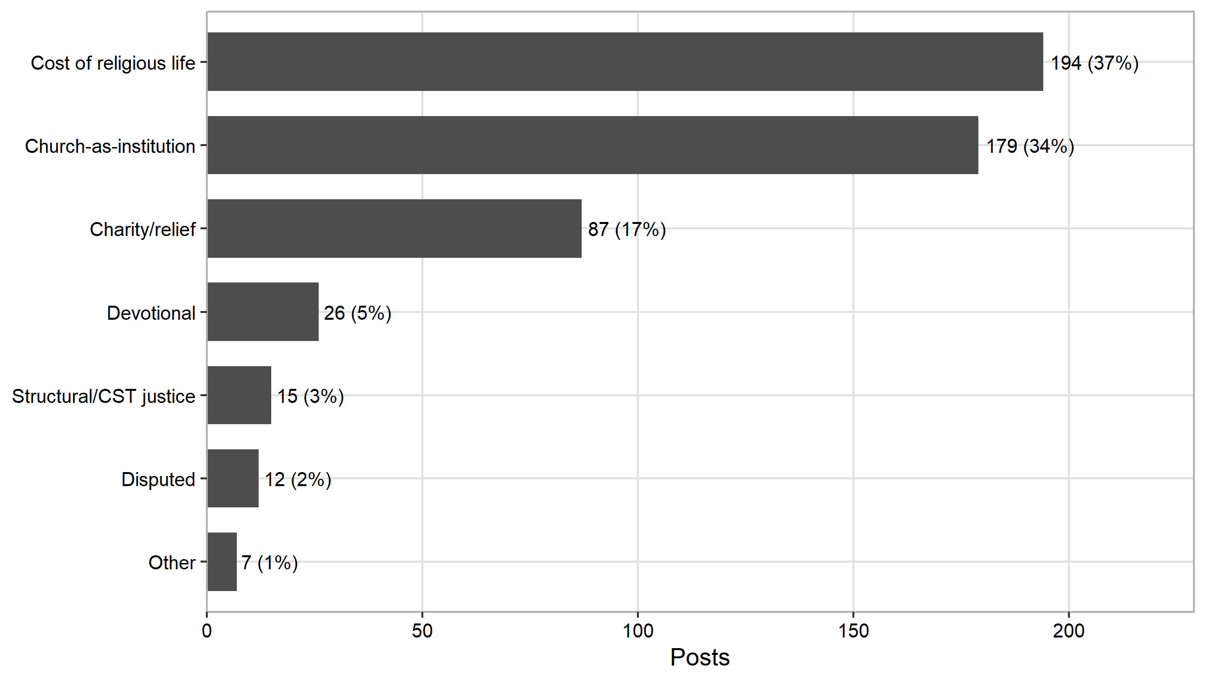
Figure 1
Source: Authors’ calculation from the DigiKat corpus.
The two dominant registers describe the Church as an economic object, not a moral voice: masses, church fees, weddings, funerals and pilgrimages that became more expensive (“cost of religious life”), and clergy or dioceses appearing in economic news as commentators or affected parties (“institution”). The second register also carries a definitional caveat. It includes clergy appearing as commentators, speaking subjects, some of whom voice moral or economic judgements, alongside the Church as an affected party. The “economic-object” reading of the ≈72% macro-register is therefore an upper bound, and splitting the institution register into subject and object is deferred to the planned human coding round (see Limitations).
The register clearly depends on who carries it, which is our second hypothesis (Table 3, Figure 2). Comparing secular and Catholic outlets across the registers, the two distributions differ sharply. A chi-square test of independence rejects the null of no association (χ²(5) = 50.4, p < 0.001, confirmed by a Monte Carlo test given the sparse cells, with Cramér’s V = 0.31, a moderate effect). The association is driven by two registers. The cost of religious life is almost entirely a secular story, since 189 of its 194 posts are secular outlets reporting that the Church raised its prices, whereas charity is relatively more Catholic. H2 is therefore supported: the register in which religion meets inflation is not the same across the media space but depends on the outlet.
The finer claim, that Catholic outlets specifically tilt toward charity (27 of 75, or 36%, of the Catholic core versus 58 of 442, or 13%, of the secular core), we do not press. The Catholic subsample is small (n = 75), 75% of it is the single aggregator hkm.hr (56 posts) whose own top register is institution (27), not charity (18), and stripping hkm.hr leaves just 19 posts. We report that direction as a hypothesis for a larger Catholic-outlet sample, not a finding. What is robust across outlets is the near-absence of the justice register (10 secular, 5 Catholic).
Table 3 Register by outlet type (counts)
Register | Secular/other | Catholic | Business
Cost of religious life | 189 | 4 | 1
Church-as-institution | 147 | 32 | 0
Charity / relief | 58 | 27 | 2
Devotional | 22 | 4 | 0
Structural / CST justice | 10 | 5 | 0
Other / disputed | 16 | 3 | 0
Source: Authors’ calculation from the DigiKat corpus.
Figure 2 Register composition by outlet type (shares)
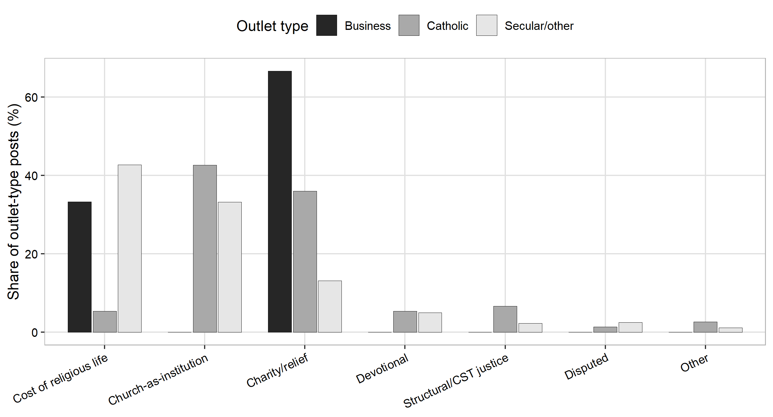
Figure 2
Source: Authors’ calculation from the DigiKat corpus.

Temporal dynamics
The measured core tracks the shock itself over the six years (Figure 3, Table 4). It rises sharply to a peak of 201 posts in 2022, at the height of the energy shock, and then declines as prices stabilise, to 100 posts in 2023, 88 in 2024, 66 in 2025, and 53 in the first half of 2026. Attention builds as prices climb and recedes as they ease. Because collection intensity varied over the period, the exact year-to-year figures are indicative, but the rise and fall are clear.
Figure 3 Measured core volume by year
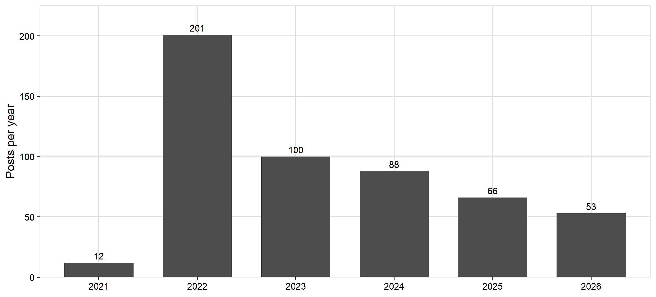
Figure 3
Note: 2026 covers only the first half of the year. Source: Authors’ calculation from the DigiKat corpus.
The register composition also shifts over the period (Figure 4, Table 4). The institution register dominates the 2022 shock, with 105 posts of clergy commenting on the crisis, and then recedes, to 38 posts in 2023 and 9 in 2024. The cost-of-religious-life register moves the other way, climbing to 61 posts in 2024 as churches revise their fees around the euro changeover of 1 January 2023. The discourse thus appears to migrate from acute-crisis commentary toward institutional price adjustment. The changeover was itself a cross-sectoral media event that prompted price-transparency and rounding-up coverage across the whole economy, so part of the cost-of-religious-life rise around it plausibly reflects changeover journalism rather than inflation alone. We treat this shift as suggestive rather than established. At no point over the six years does the justice register gain traction.
Table 4 Register by year (counts, full core)
Year | Institution | Cost-relig-life | Charity | Devotional | Justice | Other/disputed
2021 | 8 | 0 | 0 | 1 | 2 | 1
2022 | 105 | 41 | 34 | 13 | 1 | 7
2023 | 38 | 39 | 11 | 5 | 5 | 2
2024 | 9 | 61 | 12 | 0 | 4 | 2
2025 | 16 | 13 | 26 | 4 | 2 | 5
2026 | 3 | 40 | 4 | 3 | 1 | 2
Note: 2026 covers only the first half of the year. Source: Authors’ calculation from the DigiKat corpus.
Figure 4 Register over time, by year (measured core)
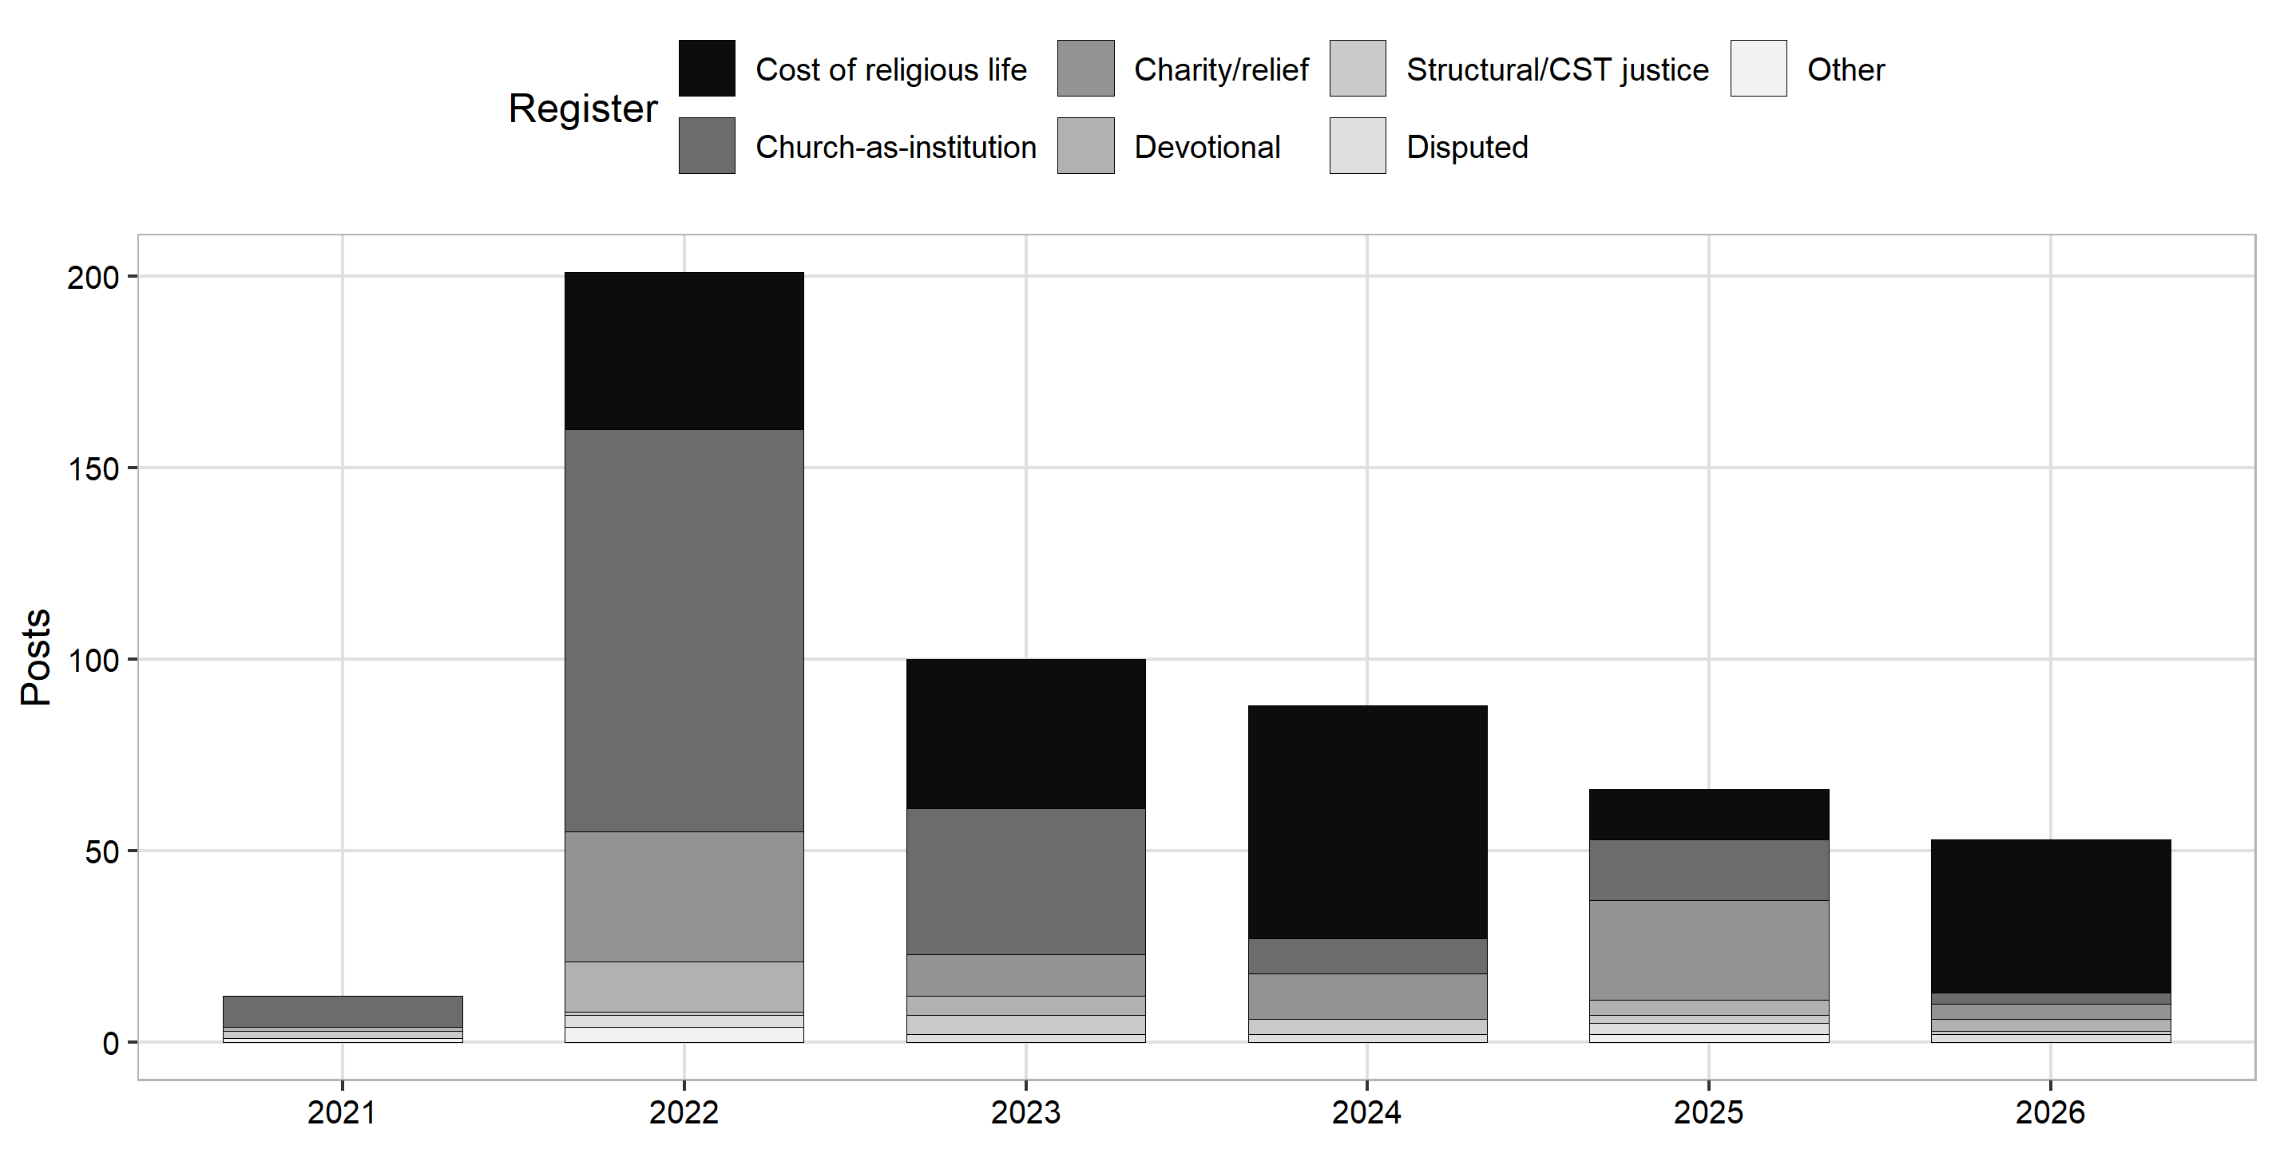
Figure 4
Source: Authors’ calculation from the DigiKat corpus.

Tone
Tone is our third hypothesis, and it too depends on the register (Table 5, Figure 5). The tone labels here come from the monitoring vendor’s automatic sentiment tool and are indicative rather than validated, so we read this test as exploratory. Across the five substantive registers, a chi-square test rejects the null that tone and register are independent (χ²(8) = 48.8, p < 0.001, Cramér’s V = 0.22, a small-to-moderate effect). The pattern is intuitive. Across these five registers (n = 501) the split is 43% negative, 32% positive, and 25% neutral, but the cost of religious life is markedly negative (100 of 194, or 51%), consistent with public complaint about church price rises, whereas the Church as an institution is the most positive register (83 of 179, or 46%), consistent with pastoral or commentary framing. The rare justice posts lean negative (9 of 15). H3 is therefore supported, subject to the caveat that a human-validated sentiment measure is needed before the result is treated as more than suggestive.
Table 5 Auto-sentiment by register (counts, vendor labels, indicative)
Register | Negative | Neutral | Positive
Cost of religious life | 100 | 56 | 38
Church-as-institution | 51 | 45 | 83
Charity / relief | 38 | 12 | 37
Devotional | 15 | 8 | 3
Structural / CST justice | 9 | 4 | 2
Source: Authors’ calculation from the DigiKat corpus (vendor auto-sentiment labels, indicative only).
Figure 5 Auto-sentiment by register (shares)
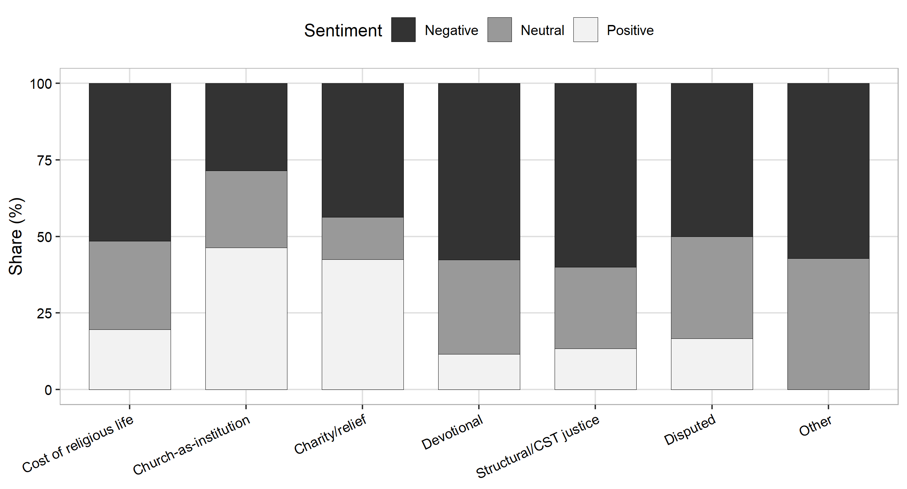
Figure 5
Source: Authors’ calculation from the DigiKat corpus.

Inflation attention and real prices
To test the first hypothesis we relate monthly inflation-attention, the share of corpus posts that mention inflation, to the Croatian HICP annual rate of change for headline, food, and energy prices. The monthly test covers the 39 months from 2021 to mid-2024, the window for which we built the monthly attention series. The series runs continuously through January 2024 and then has two sparse months, June and July 2024, so it is not fully contiguous at the end. Over this window attention tracks inflation strongly (Table 6, Figure 6). The correlation with headline HICP is Pearson r = 0.73 (nominal p < 0.001, with the cautions noted below), 0.72 with food, and 0.44 with energy, and the Spearman ranks are comparable. The threshold pattern also holds. Mean attention is 0.49% of posts in the 12 months when headline HICP is below 4%, and 1.17% in the 27 months at or above it, a 2.4-fold jump around the 4% threshold documented in other countries. A two-sample test confirms the gap (Welch t = 5.7, p < 0.001, Cohen’s d = 1.7, with a rank test giving the same result), though the caution below about autocorrelation applies here too.
Three cautions temper the inference. First, the HICP annual rate of change compares each month with the same month a year earlier, so consecutive monthly values overlap by eleven months and move together closely. The attention series is also persistent. The number of genuinely independent observations is therefore well below the nominal 39, and the p-value overstates the precision. We plan an autocorrelation-robust re-estimate and a month-on-month version before submission, and until then the correlation should be read as descriptive. Second, the 4% cutpoint is taken from the cross-national literature, not estimated from these data. With only 39 months the data cannot locate a breakpoint of their own, and the two-sample test above assumes a cutpoint rather than finding one. Because the 12 below-threshold months sit mostly at the start of 2021, that contrast cannot fully separate a genuine jump from the smooth rise already described. Third, the January 2023 euro changeover flooded every sector with price coverage, so part of the 2023 attention is plausibly changeover journalism rather than a reaction to the inflation rate itself.
On this evidence the hypothesis is partially supported. The coupling and the threshold pattern hold, and food inflation tracks attention as strongly as the headline rate does, but energy couples only weakly (r = 0.44). Energy prices swung widely and often turned negative in 2023 and 2024, which loosened their link to attention, so the “food-and-energy” part of the prediction holds for food but not for energy. This component reading is indirect, because we relate overall attention to each price component rather than to component-specific attention, so the weak energy result is suggestive rather than decisive. The coupling is not an artifact of the ragged tail of the window. It is r = 0.77 on the fully continuous 2021 to 2023 block (n = 36) and r = 0.72 once the sparsest tail month is dropped. The religion-linked core is too small for a monthly test of its own, but its yearly volume aligns with inflation, since both peak in 2022.
Table 6 Inflation-attention versus HICP (monthly, 2021 to mid-2024, 39 months, not fully contiguous)
HICP component | Pearson r | Spearman ρ
Headline | 0.73 | 0.75
Food | 0.72 | 0.74
Energy | 0.44 | 0.43
Source: Authors’ calculation from the DigiKat corpus and Eurostat.
Figure 6 Inflation-attention versus HICP, 2021 to mid-2024
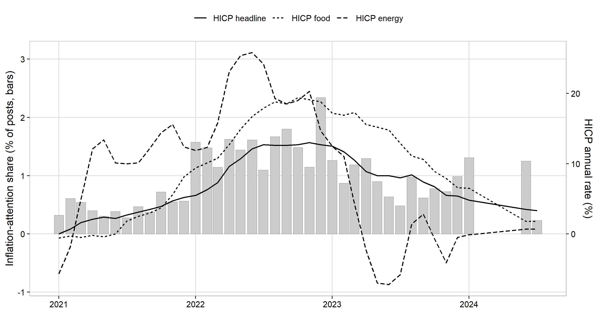
Figure 6
Note: Bars show the share of corpus posts mentioning inflation (left axis). Lines show the Croatian HICP annual rate of change (right axis). Source: Authors’ calculation from the DigiKat corpus and Eurostat.

Formal tests of the three hypotheses
Table 7 gathers the three formal tests in one place. All three reach significance, and two rest on the validated coded data (register and outlet), while the tone test rests on the vendor sentiment labels and is read as exploratory. The effect size is moderate for the outlet test (Cramér’s V = 0.31), small-to-moderate for the tone test (V = 0.22), and large for the attention threshold. The tests move the study one step beyond description: the register in which religion meets inflation is not the same across outlets (H2), and its tone is not the same across registers (H3), while attention itself rises with prices (H1).
Table 7 Formal tests of the three hypotheses
Hypothesis | Test | Statistic | p | Effect size
H1: attention rises with prices | Pearson correlation, monthly (n = 39) | r = 0.73 | < 0.001 (nominal) | large
H1: 2.4-fold jump above 4% | Welch two-sample t-test | t = 5.7 | < 0.001 | Cohen’s d = 1.7
H2: register depends on outlet | Chi-square of independence (2 × 6) | χ² = 50.4, df = 5 | < 0.001 | Cramér’s V = 0.31
H3: tone depends on register | Chi-square of independence (5 × 3) | χ² = 48.8, df = 8 | < 0.001 | Cramér’s V = 0.22
Note: H1 covers 2021 to mid-2024, and its months are autocorrelated, so its p-values are read as descriptive (see the cautions above). The H2 p-value is confirmed by a Monte Carlo test because several cells are sparse. The H3 test uses the vendor sentiment labels and is exploratory. Source: Authors’ calculation from the DigiKat corpus and Eurostat.

DISCUSSION
The dominant way religion meets inflation in Croatian digital discourse is not the pulpit but the price list, and the Church appears throughout as an economic object rather than a moral voice. Seven in ten linked posts describe either the rising cost of religious life or the Church as an institution caught up in economic news. Together these make up the 72% economic-object macro-register, which is itself an upper bound, since the institution register also holds clergy who speak as commentators (see Results). Charity adds a sixth of the posts, and the structural-justice critique that CST foregrounds is marginal, at 3% under strict coding and at most 8% broadly construed. We read this as a claim about what is visible in the digital public sphere, not about the Church’s pastoral conduct. Homilies, pastoral letters, and Caritas fieldwork are largely absent from a corpus of news posts, so the low visibility of the justice frame is weak evidence about institutional silence itself (see Limitations). What the data support is that, in the national digital public sphere, the frame that surfaces around inflation is overwhelmingly the fee and the institution, not the prophecy.
Newsroom gatekeeping offers a rival explanation. The register distribution is produced by editorial selection at least as much as by what religious actors say. Standard news values, such as conflict, concrete numbers, and institutional controversy, favour the church-fee story over the pastoral letter: a diocese raising the price of a funeral is news, while a homily on structural poverty rarely is. Since 85% of the measured core is secular outlets’ output, the distribution we observe is largely what newsrooms judged newsworthy about religion during the shock. The “quiet prophets” pattern may therefore be partly editorial deafness rather than clerical silence. On the present data, the two readings, a Church that does not speak structurally, and media that do not relay it when it does, cannot be separated. The planned secular benchmark and a supply-side corpus of Church-authored texts (see Limitations) are designed to separate them.
Attention existed, but a prophetic voice did not fill it. The two results interlock. The attention test shows that media attention to inflation is real and moves with prices (see Results). Yet within that attention, once linkage is measured, the religious engagement is small and, where present, non-prophetic. The public conversation about inflation was there for a religious justice voice to enter, but little of one is visible in the measured discourse.
A possible division of narrative labour emerges, though it remains a hypothesis. The register-outlet pattern hints at two storytellers. Secular media supply the “costlier candles” story, reporting, often critically and in a negative tone, that the Church raised the price of masses, weddings and funerals around the euro changeover. Catholic outlets, in their thin non-aggregator tail, lean instead toward “quiet charity.” As noted above, the Catholic subsample is too small and too aggregator-dominated to establish this contrast, so we advance it only as a hypothesis. What both kinds of outlet share is the near-absence of the prophetic, structural voice.
Mechanism and timing also matter here. The pattern fits an agenda-setting reading. The religious linkage flares during the acute 2022 shock, mostly as institutional commentary, and recedes as prices stabilise, while church-fee coverage rises around euro adoption. On this evidence the dynamic looks closer to resonance than to setting, in line with proposition P1, though only provisionally. Religion enters inflation discourse reactively, as an affected party, rather than as an agenda-setter for economic justice.
This finding matters across three fields. For sociology of religion, it qualifies accounts of the Croatian Church as a strong public actor: on the economy, at least, its digital-public presence is thin and non-prophetic. For media studies, it extends inflation-salience research into the religious sphere and shows that the “who is hurt” framing has a specifically institutional variant: “who charges more.” For CST scholarship, the absence poses the question of why the doctrinal justice frame does not travel into the national digital public sphere.
Three implications for social policy follow. First, agenda-setting research suggests that media frames shape which policy responses the public sees as warranted. If so, a digital sphere in which religion meets inflation as fees and institutional news, rather than as structural injustice, does little to build public support for redistributive or anti-poverty responses to a cost-of-living shock, even though doctrine points exactly there. Second, the visible charity register (17%) shows the place the country’s main faith-based relief network holds in the digital public sphere. Caritas appears as an episodic relief actor rather than as an advocate for structural reform. This is the familiar charity-versus-justice tension in faith-based welfare, here measured rather than asserted. Third, the dominant cost-of-religious-life register points to a concrete social-policy object. For religiously observant low-income households, fees for weddings, funerals, and other rites of passage are close to obligatory expenses. They are a neglected part of cost-of-living measurement, which the church-fee resets around the euro changeover made briefly and unusually visible.
To summarize the scorecard (Table 7, Appendix C), the three tested hypotheses are borne out, H1 only partially. Attention rises with prices (H1, partially supported, since energy couples only weakly), the register depends on the outlet (H2, supported by chi-square), and the tone depends on the register (H3, supported but exploratory on vendor sentiment). Of the three propositions, resonance rather than setting is provisionally consistent (P1, pending a lead-lag test), the prophetic-actor proposition is not visible in the digital-news measure (P2, though a news corpus cannot test the actor-level claim), and episodic-over-thematic framing is supported, in part by construction (P3).

METHODOLOGICAL CONTRIBUTION: CO-OCCURRENCE IS NOT ENGAGEMENT
Independent of the substantive story, the study is a cautionary demonstration. Had we counted co-occurrence, we would have reported thousands of “religious engagements with inflation.” Measured, genuine domestic linkage is 520 posts. The gap is not noise to tolerate but signal to remove: keyword-filtered corpora manufacture incidental co-mention at scale. Our pipeline, combining anchored lexicons with metaphor and homonym guards, a recall-oriented proximity filter, and multi-annotator coding with reported inter-annotator agreement, is a reusable template for any “religion and X” (or “A and B”) corpus study.

LIMITATIONS
Several limitations qualify these findings. Collection intensity was not perfectly uniform across the six years, so the year-to-year volumes should be read as indicative and the exact size of the post-2022 decline is uncertain. The rise to the 2022 peak and the broad decline afterwards are robust, but the precise annual counts are not. Inter-annotator agreement is high (0.97), but this is agreement between models, not a human gold standard. Before final publication we plan a human double-coding of at least 100 posts, including the foreign-versus-domestic decision that defines the core of 520, together with a resolution of the 12 “disputed” register cases. The Church-as-institution register is also mixed. It counts both the Church as an affected party and clergy speaking as commentators, so the economic-object reading of the 72% macro-register is an upper bound. The planned human round will split this register into affected party and commentator and recompute the figure on that split. Finally, even after majority coding a few posts are misclassified, so a high-confidence subset of 518 posts on which all three annotators agreed is available for sensitivity analysis.
Register was the lowest-agreement axis, and the 37% versus 34% ordering is within noise, which is why we report the ≈72% macro-register, while 3% justice is a strict floor, at most 8% broadly construed. The proximity filter’s misses may also be register-non-random, since long-form thematic argument is likelier to exceed a ±220-character window, so filter design as well as strict coding may depress the justice floor, and a planned window-sensitivity check addresses this. The attention-price test is also conducted only at the level of corpus-wide inflation-attention. A monthly HICP overlay on the religion-linked core specifically is too sparse to test, and the lead-lag test of resonance against public search interest is future work.
Because the corpus is religion-filtered, we cannot yet say whether structural framing is rarer in religious than in secular inflation coverage, and a benchmark on non-religious inflation posts is needed before any claim that the Church specifically underuses the justice frame. Finally, “secular” here means secular outlets’ religion-adjacent output, not their full inflation coverage, and the core is also 96% web, so claims generalize to the web-portal public sphere rather than to all platforms.

CONCLUSION
When prices rose in Croatia, religion did enter the digital conversation about inflation, but as an institution whose candles, masses and fees had become more expensive, and whose charities responded, far more than as a prophetic voice for the poor. Media attention to inflation tracked real prices closely, but the religious structural-justice frame did not fill that attention. Costlier candles, quiet prophets. Whether this reflects a genuinely quiet Church, newsroom gatekeeping that finds fees more newsworthy than prophecy, or a justice voice carried in channels a news corpus does not capture, is the question the absence opens. The planned secular benchmark and supply-side corpus of Church-authored texts are designed to answer it, with a lead-lag test and human validation securing the ground beneath them.

DATA AND CODE AVAILABILITY
The aggregate outputs behind every table and figure, together with the coded data and the HICP price series, are available on request. The underlying corpus contains scraped post text and is not redistributable, so the analysis is reproducible from the aggregate data and the analysis scripts rather than from the raw corpus. The measured-core file carries URLs and text excerpts and is held internally pending a statistical-disclosure review.

ETHICS AND DISCLOSURE
The corpus consists of publicly posted media content collected via a commercial monitoring service. The paper reports only aggregate counts and shares. No personal data, account identifiers, or verbatim private content are published. Outlet names are public publishers. A disclosure/PII screen is run before any data extract is shared.

ACKNOWLEDGMENTS
This research was conducted within the DigiKat project at the Catholic University of Croatia (Hrvatsko katoličko sveučilište), Department of Communication Studies. This is a working manuscript (first complete version, 1 July 2026), and authorship and author order are to be finalized. It is released under CC BY 4.0, and open-science (FAIR) principles apply.

REFERENCES
- Aarab, I., Bańbura, M., Bobeica, E., & Leguay, T. (2025). Tracking inflation attention. ECB Economic Bulletin 6/2025.
- Benedict XVI (2009). Caritas in Veritate.
- Champagne, C., et al. (2024). “Heating or eating”: framing the cost-of-living crisis. Social Science & Medicine, 360, 117312.
- Francis (2013). Evangelii Gaudium.
- Geiß, S. (2022). Conditional agenda-setting. Communication Research, 49(2), 296–323.
- Gutiérrez, G. (1971/1973). A Theology of Liberation. Orbis.
- Iyengar, S. (1991). Is Anyone Responsible? University of Chicago Press.
- Korenok, O., Munro, D., & Chen, J. (2026). Inflation and attention thresholds. Review of Economics and Statistics, 108(3), 842–850.
- Lamla, M. J., & Maag, T. (2012). The role of media for inflation expectations. Journal of Money, Credit and Banking, 44(7), 1325–1350.
- McCombs, M. (2004). Setting the Agenda: The Mass Media and Public Opinion. Polity Press.
- McCombs, M. E., & Shaw, D. L. (1972). The agenda-setting function of mass media. Public Opinion Quarterly, 36(2), 176–187.
- Pfäuti, O. (2024). The inflation attention threshold. arXiv:2308.09480.
- Wlezien, C., & Soroka, S. (2024). Media and the public’s attention. American Political Science Review, 118(3), 1563–1569.
- Yin, R. K. (2018). Case Study Research and Applications: Design and Methods (6th ed.). Sage.
Some literature entries remain to be verified against Hrčak and CrossRef before submission. The price data are the Croatian HICP annual rate of change (all items, food, and energy, monthly) from Eurostat, retrieved on 1 July 2026.

APPENDIX A. REPRODUCIBILITY
The analysis proceeds in five stages. We first tag inflation mentions and identify candidate religion-inflation links in the corpus. We then assemble the 1,450-candidate pool and prepare it for coding. Three annotators code the pool independently, and their labels are combined by majority. From the coded pool we derive the measured core, and from the core we compute the register, outlet, and sentiment tables and figures, the three formal hypothesis tests (the attention-price correlation and threshold test, and the two chi-square tests), and the attention series against HICP. The analysis scripts and the coded data behind every table and figure are available on request. The underlying corpus of scraped post text is not redistributable.

APPENDIX B. CODING PROTOCOL AND VALIDATION
The four coding axes are described in the Data and Methods section. In held-out validation (n = 80), inter-annotator agreement was 0.975 for inflation, 0.967 for linkage, 0.992 for foreign versus domestic, and 0.46 for register. The proximity filter’s held-out precision for domestic linkage was about 0.38 to 0.46, with a recall of about 0.89. Full-pool coding confirmed that 45% of candidates were genuinely linked.

APPENDIX C. HYPOTHESIS SCORECARD
Table C1 Hypothesis scorecard
# | Statement | Test | Verdict
H1 | Attention rises with HICP and jumps above about 4%, with food and energy at least as salient as the headline | Correlation and threshold t-test | Partially supported (r = 0.73, the threshold jump significant at t = 5.7, food tracking the headline but energy coupling only weakly at r = 0.44)
H2 | The register depends on the type of outlet | Chi-square of independence, register × outlet | Supported (χ²(5) = 50.4, p < 0.001, Cramér’s V = 0.31), driven by the cost of religious life being a secular story
H3 | The tone depends on the register | Chi-square of independence, register × tone | Supported, exploratory (χ²(8) = 48.8, p < 0.001, Cramér’s V = 0.22) on vendor sentiment labels
P1 | Religious coverage resonates rather than leads | Temporal pattern (pattern-matching) | Provisionally consistent, with a lead-lag test still pending
P2 | If prophetic actor, justice register non-trivial and rises with hardship | Register distribution (pattern-matching) | Not visible in the digital-news measure (3% under strict coding, at most 8% broadly, with no rise over time), since the actor-level claim is not testable in a news corpus
P3 | Framing episodic, not thematic | Register distribution (pattern-matching) | Supported (episodic registers $gg$ thematic justice), though partly by construction, since justice is by definition the thematic register
Source: Authors’ compilation.

Sažetak
SKUPLJE SVIJEĆE, TIHI PROROCI: KAKO SE RELIGIJA SUSREĆE S INFLACIJOM U HRVATSKOME DIGITALNOM MEDIJSKOM PROSTORU, 2021.–2026.
Luka Šikić, doc. dr. sc. Hrvatsko katoličko sveučilište, Odjel za komunikologiju Zagreb, Hrvatska
Petra Palić, izv. dr. sc. Hrvatsko katoličko sveučilište, Odjel za komunikologiju Zagreb, Hrvatska
Mislav Sagovac, dr. sc. Hrvatsko katoličko sveučilište, Odjel za komunikologiju Zagreb, Hrvatska
Katolički socijalni nauk (KSN) poziva Crkvu da inflaciju imenuje kao nepravdu prema siromašnima. Pitamo kako taj glas doista zvuči u nacionalnome digitalnom medijskom prostoru tijekom šoka troškova života. Iz korpusa DigiKat od 710 307 religijski relevantnih hrvatskih i bosanskih objava (2021.–2026.) izdvajamo spomene inflacije i razlikujemo istinsku povezanost religije i inflacije od slučajnoga supojavljivanja. Nakon kodiranja 1 450 kandidata s trima jezičnim modelima ostaje izmjereni domaći korpus od 520 objava. U njemu se religija s inflacijom susreće pretežno kao s gospodarskim predmetom: rastući trošak religijskoga života i Crkva kao institucija zajedno čine oko 72 % objava, dok registar strukturne pravde koji KSN ističe doseže najviše 8 %. Medijska pozornost prati stvarne cijene (Pearsonov r oko 0,73), no religijski glas pravde ne ispunjava tu pozornost. U korpusima filtriranima ključnim riječima supojavljivanje nije angažman, a povezanost treba mjeriti, a ne brojati.
Ključne riječi: digitalna religija, istaknutost inflacije, katolički socijalni nauk, medijsko uokvirivanje, postavljanje dnevnoga reda, Hrvatska, računalna analiza teksta.

